The Industrial Achievement Award    Young  Author  Award |  | 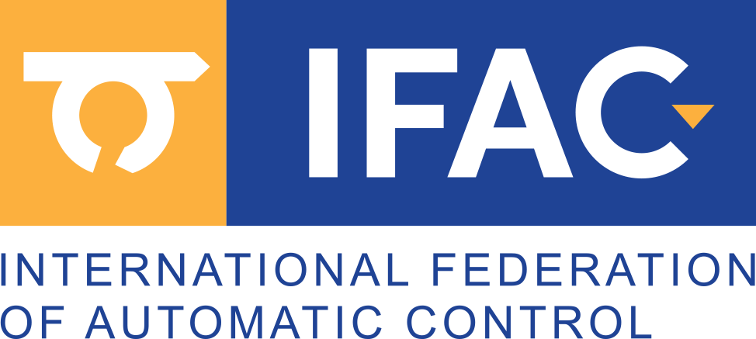  is presented to:  Max Mustermann  for the application of advanced control technologies in the nano-domain to magnetic tape data storage  Presented by  XY

