The Industrial Achievement Award    Young Author  Award  (Finalist) |  | 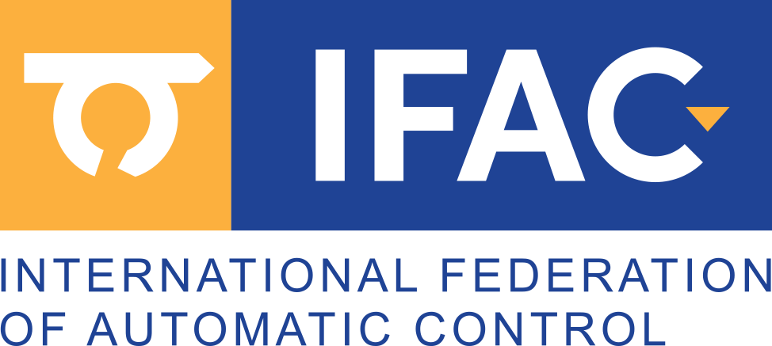  Max Mustermann  has been awarded an  Honorable Mention  as one of six finalist papers for the Young Author Award at the EVENT NAME in city, country  for the paper entitled  On the Connection between Nash Equilibria and Social Optima in Electric Vehicle Charging Control Games  co-authored by K. Willixhofer and Elske Haberl  Presented by  Max Mustermann  Affiliation

